INSTRUCTIONS FOR PREPARING THE EXTENDED ABSTRACT (14pt,

Bold)

¹N. Surname*, ²B. C. Author (11pt, Normal)
¹University of Ljubljana, Faculty of Mechanical Engineering, Ljubljana, Slovenia (11pt, Normal)
²Iskra Mehanizmi, Lipnica, Slovenia

Keywords: (11pt, Bold)

5 Keywords, font size 11, normal print, regular letters

*Corresponding author: Name Surname: e-mail address (9pt, Normal)

1. Introduction (11pt, Bold)

Please, provide the affiliations as shown with the example above. Do not include telephone numbers. Include the e-mail address for the corresponding author only. Mark the corresponding author with an asterisk (no matter the position in the list of authors). The presenting author should be underlined (no matter the position in the list of authors).

Due to the editing of the papers, file in MS Word format prepared in accordance with these instructions is required. Authors who are not native English speakers must find a lector by themselves and thus assure the quality of the paper.

If there is more than one paragraph within a chapter, leave one line of space between paragraphs and each paragraph starts at the beginning of the line (no indentation).

The extended abstract should be limited to maximum 2 pages, including all subsections of these instructions. Pages must not be numbered.

2. Experimental setup (11pt, Bold)

2.1. Page setup (11pt, Normal)

Do not change any of the font styles or sizes used on this page. Use the page format presented in these instructions, i.e. using the following margins:
- top margin: 30 mm,
- bottom margin: 20 mm,
- left margin: 20 mm,
- right margin: 20 mm.

The whole text must be written with ‘Times New Roman’ font and ‘single’ spacing. For the Main title use font size 14, bold print, capital letters, centred alignment; for Chapter titles (i.e. Introduction, Experimental, Results and Discussion, Conclusions…) use font size 11, bold print, regular letters, left alignment and for Sub-Chapter titles font size 11, normal print, regular letters, left alignment. All chapters and sub-chapters should be numbered.

Leave two lines of space between each chapter and one after the chapter title. If sub-chapters are used, leave one line of space before and after the sub-chapter title. Text in the chapters is written with font size 11, normal print, regular letters, justified alignment and paragraphs divided by one line of space. Paragraphs start at left margin (without indentation).

If necessary, please use additional line(s) of space to move a chapter title from the bottom of a column to the beginning of the next column.

3. Results and discussion (11pt, Bold)

Tables and Figures must be inserted in the text, close to the place where first mentioned and have a centred alignment (within a single column). Tables and Figures must be equipped with number and title (tables and figures are numbered separately), using font size 10, regular letters, and centred alignment. Table/Figure and number in bold print must be followed by Table/Figure title in normal print.

Table title with a table number must be positioned above the table. Before and after the title of the table leave one line of space. Below the table leave two lines of space.

Table 1:(10 pt, Bold) Testing conditions (10pt, Normal)

Parameter | Test 1 | Test 2 | Test 3
Contact pressure [MPa] | 10 | 100 | 1000
Sliding velocity [m/s] | 0.001 | 0.01 | 0.1
Condition [unit] | x | y | z

Before and after the figure leave one line of space. Figure title with a figure number must be positioned below the figure. Below the title leave two lines of space. Please use high resolution figures with letters big enough to be readable. Photographs and micrographs should contain a scale, describing the length.

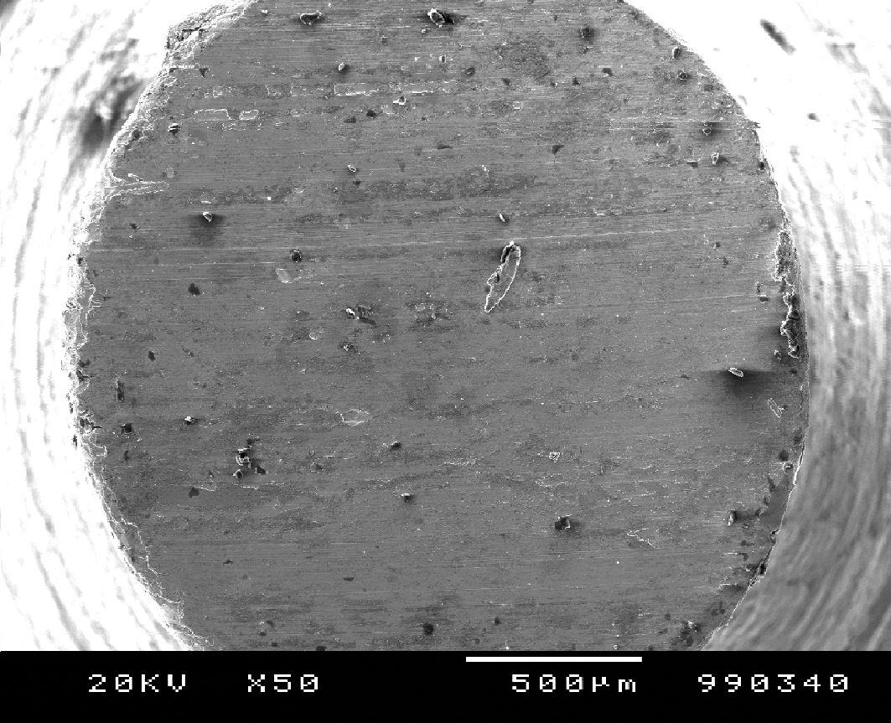

Figure 1:(10pt, Bold) Ball wear scar (10pt, Normal)

References should be quoted successively in the text and quotations placed in angular brackets [1]. Each quotation of the reference in the text must be in the Reference chapter and vice-versa.

For the Reference chapter title use font size 11, bold print, regular letters, left alignment. Leave one line of space before starting with listing of references. Individual references are written in font size 10, normal print, regular letters, left alignment. Paragraphs have hanging indentation of 7.5 mm and numbers in square brackets. Between individual quotations there is no line spacing.

4. Conclusions (11pt, Bold)

The extended abstract should contain all the relevant sections, describing your work. The Introduction should explain about the purpose of the research, i.e., the background and the motives for your work, also citing the relevant published results of your past research and recognizing the relevant work of others. The Experimental section should contain short, concise information about the procedures, methods and equipment used in your work. In the Results and discussion section (you can also use two individual sections) you should present the major results and explain their meaning and the corresponding correlations by remaining clear, factual and objective in your narration. In the Conclusions you should shortly summarize the most important results and findings.

References (11pt, Bold)

[1] T. L. Elliott, K. Kato, Surface Hardening, Tribology International 11 (1978) 121-128.
[2] N. P. Suh, Tribophysics, Prentice-Hall, Englewood Cliffs, 1986.

nmark, 1998, 791-800.

